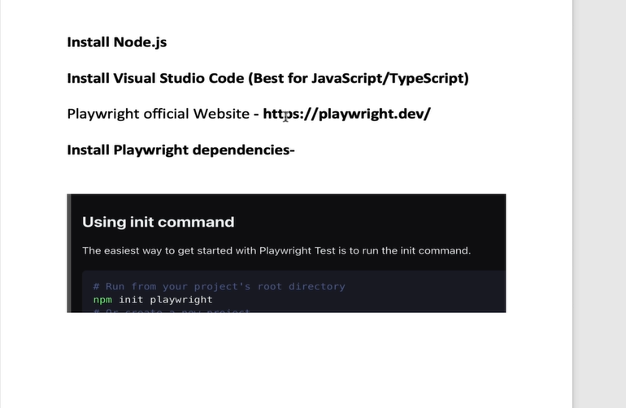

const {test}=require(‘@playwright/test’); // required to start our playwright test scripts

NOTE : {test}🡪

* this test are executed in playwright environment that launches browser and provide a fresh page to each test
* this test coming from playwright package that’s why we declare in first line. From there we can driver that reference and perform our operation.

## when you need to write test case then following syntax used

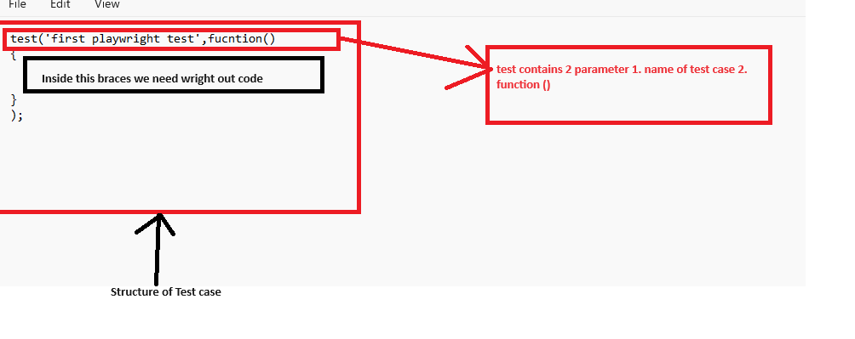

* when our function doesn’t have name then as per new version of js we can write them as lambda function like🡪fucntion ()--🡪()=>

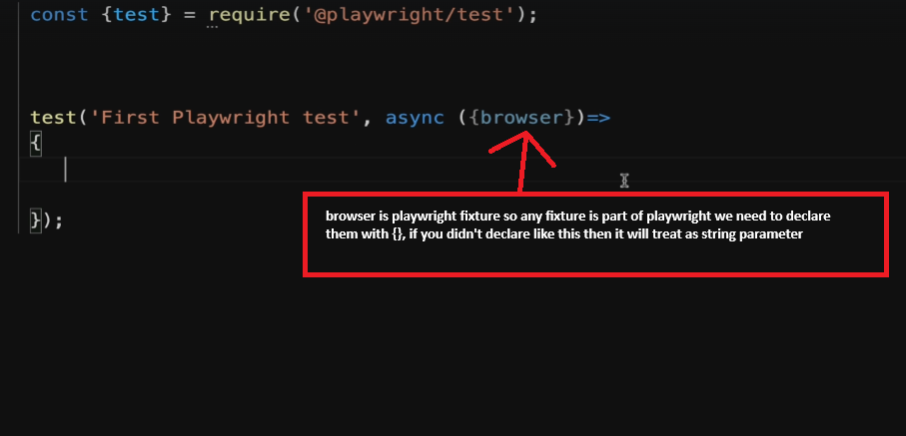

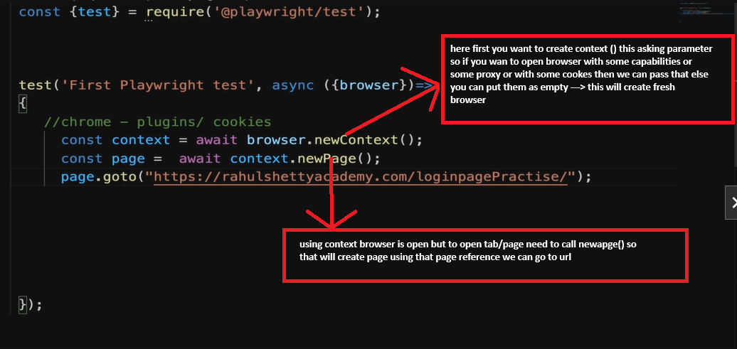

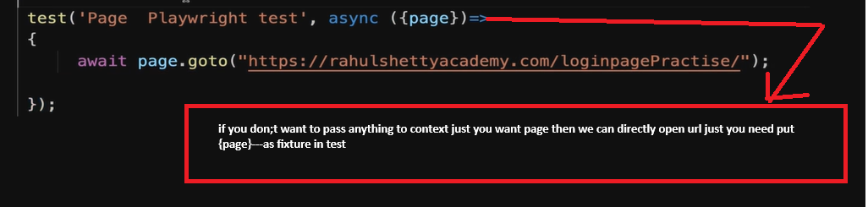

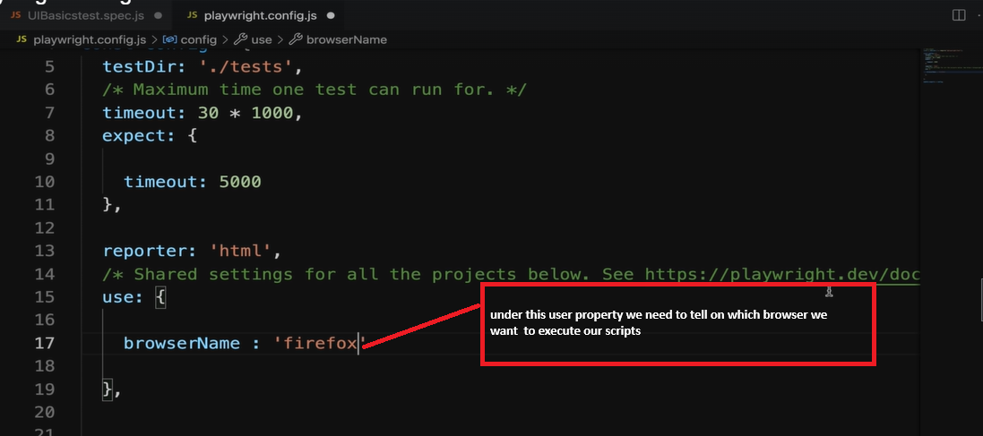

## or under user property we can mentioned **headless: false** 🡪 so it will invoke browser

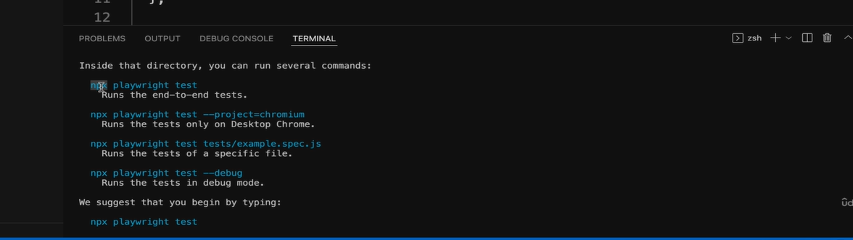

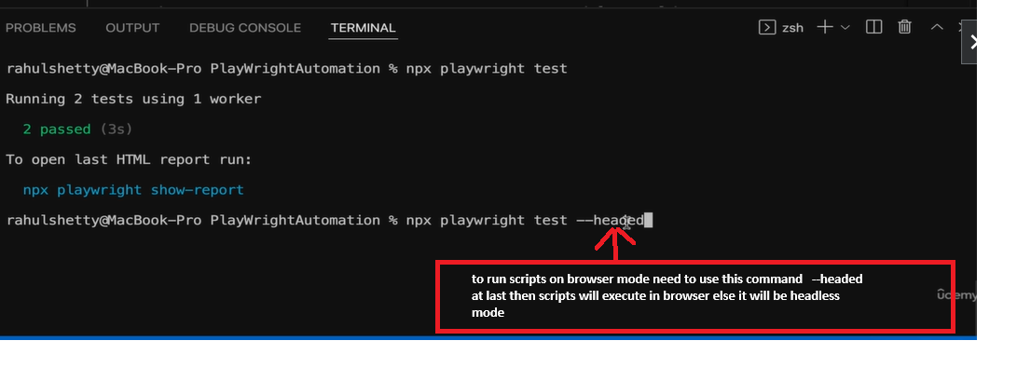

**## or under user property we can mentioned headless: false 🡪 so it will invoke browser**

## SendKeys

* In Playwright we need to use “Type” or “fill” to send something in textbox. As per new version of playwright we are using fill

Example:

**Await page.locator(#username).fill(“pravin”);**

NOTE: for particular web element is taking time so displayed in selenium we used explicit wait and it’s condition but in playwright no need to use any method , it is very smart intelligence it will wait automatically till timeout that we provided in pl;aywrightconfig.js file(timeout: 30*1000)->will wait 30 sec.

## TO Get text/ Fetch text from web page

Example:

**const page_Text=Await page.locator(#username).textContent();**

## Locators

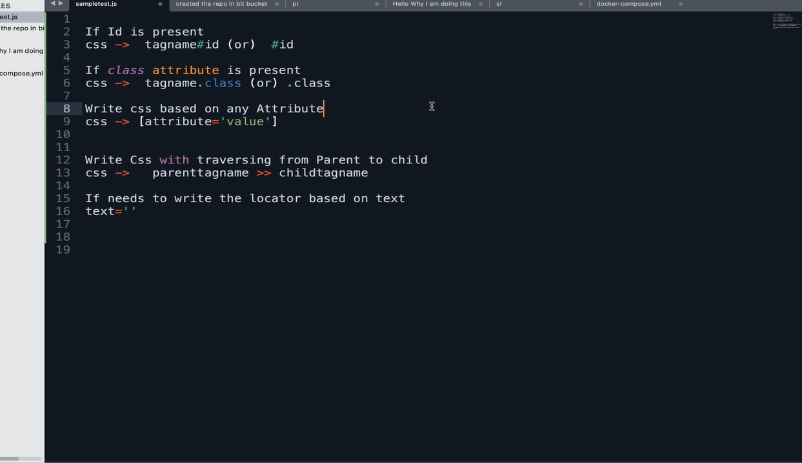

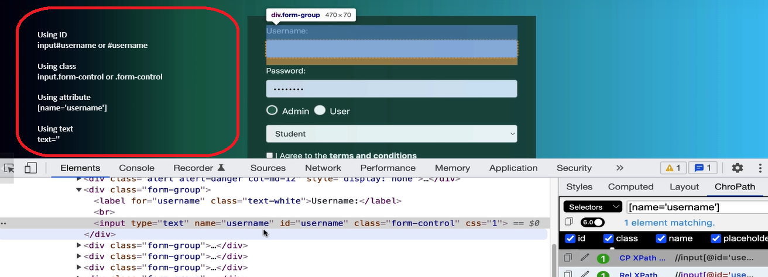

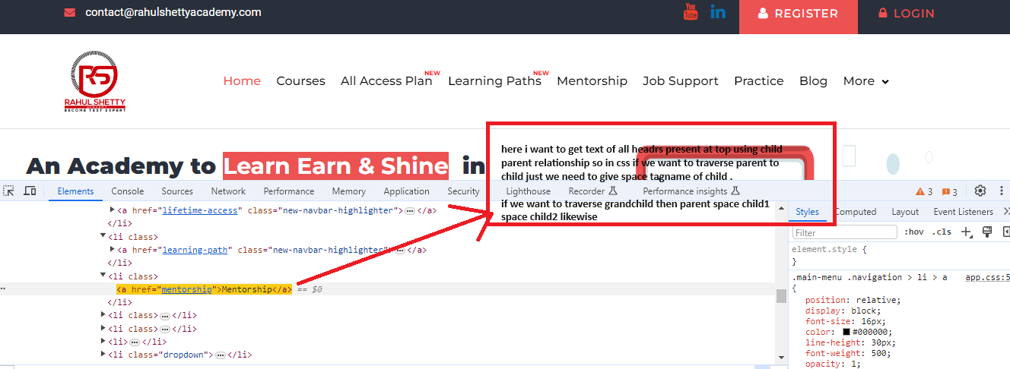

## NOTE:(Haslocator)

* If you want to search text using some tagname then playwright has some inbuild function that can helps in good way to find locators

**Example: page.locator(“h3:has-text(‘textname that we want to search’)”);**

## How to clear text box

Example:

Await page.locator(#username).fill(“”);🡪need to pass empty string that will clear username text box

## **How to text of multiple element / find elements**

Example: to get text following way we can use

* To get first element 🡪 page.locator(#username).first().textContext();
* To get second element 🡪 page.locator(#username).nth(1).textContext();
* To get third element 🡪 page.locator(#username).nth(2).textContext();
* To last element 🡪 page.locator(#username).last().textContext();
* To get text of all elements🡪 page.locator(#username).last().allTextContents();

NOTE: (get text methods)

* In selenium we know difference between find element and element, same rule apply here for textcontent() and alltextContents()
* For textContent()🡪it will wait till element not get displayed (time out we already provided )Still not present then we will get no element found
* For alltextContents()🡪it will return list of array that maybe contain 6 elements or sometimes 0 due to this it will not throw any error.

# ## Dynamic Wait (for waits please playwright documentation specially Auto-waiting🡪here we can see which method what capability it has)

# Whatever method we are using after locator to perform some action, after that it takes some time to load in web page then check that method in auto- waiting list if that present then no need to use other method but if not present in auto- waiting list then need to use waitfor() method. (like textContent() is not present , sometimes it takes few millisecond to reflects text on web pages so we can use waitfor() method to handle synchronization issue in playwright )

# in playwrights

* We want to wait till hmtl get loaded or normal load or till wait where all network call get executed this can be done.

### Wait for 🡪Hard wait not like thread.sleep()

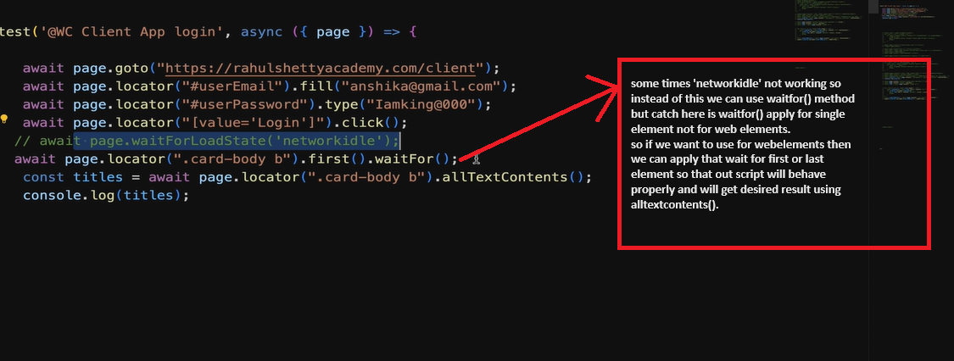

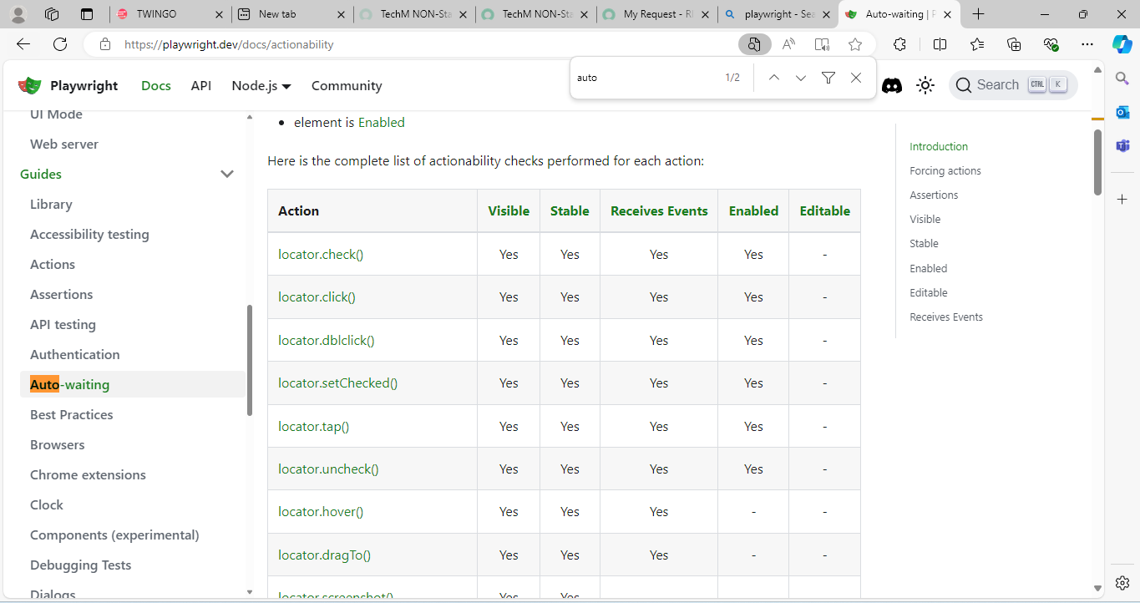

## Dropdown Handling

* We need to use [locator.selectOption()](https://playwright.dev/docs/api/class-locator#locator-select-option) -🡪 here inside option (need to pass value **[pass value attribute like value=’india’🡪selectioOption(“india”**)] of things which we are selecting ”)

For static dropdown

1. Using the **.select_option()**method with values.

Example: page.locator(“”).select_options(‘value’)🡪

1. Using **.select_option()** method with Label.

Example: page.locator(“”).select_options(label=‘value’)🡪

1. . Using**javascript**.

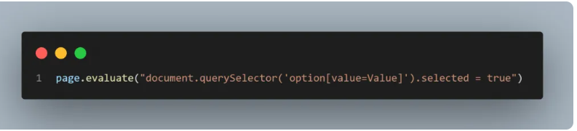

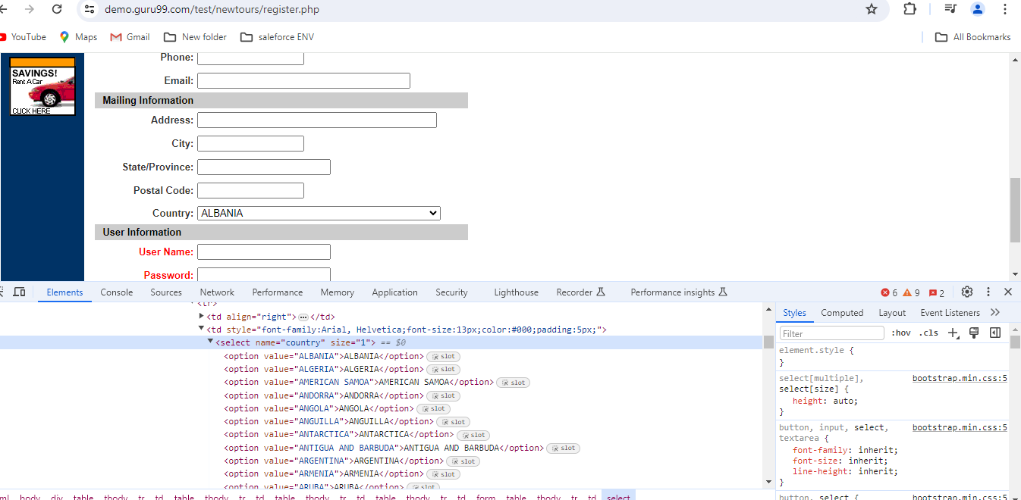

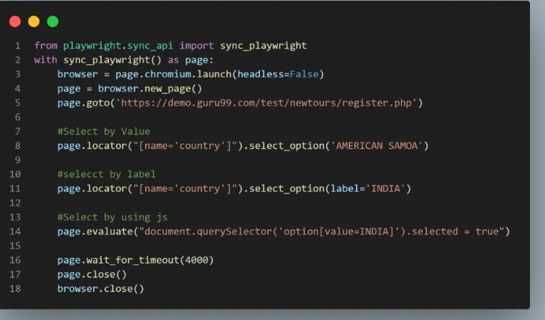

## Auto suggestive dropdown

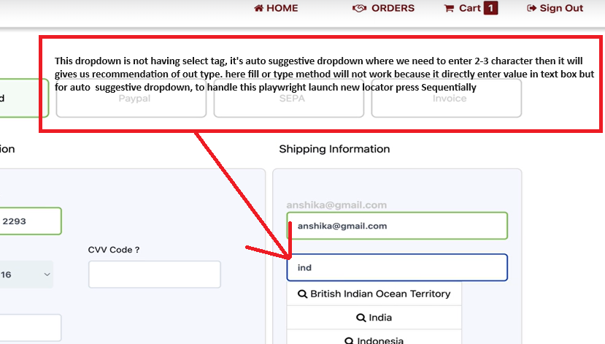

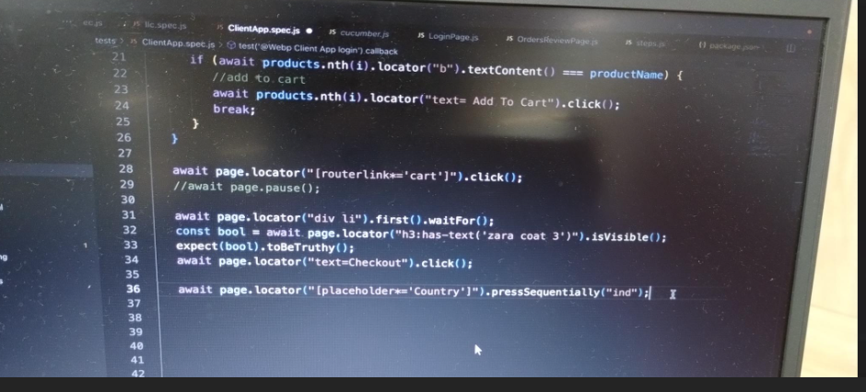

Alternative for press sequentially

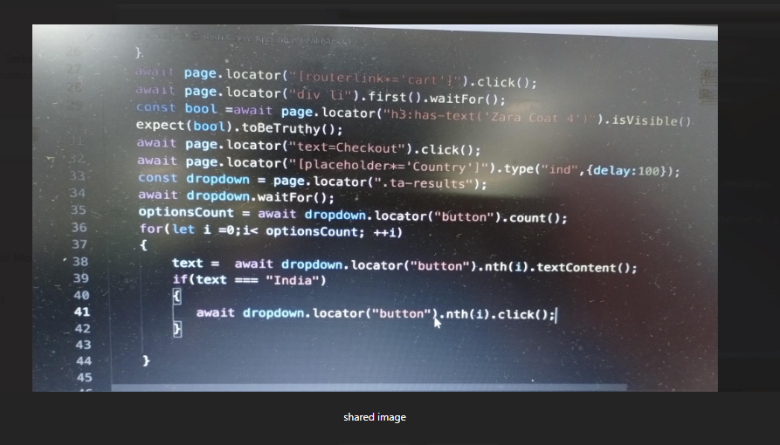

## Handling dropdown list

* Instead of === we can use javascripts method includes (text.include(“india”))

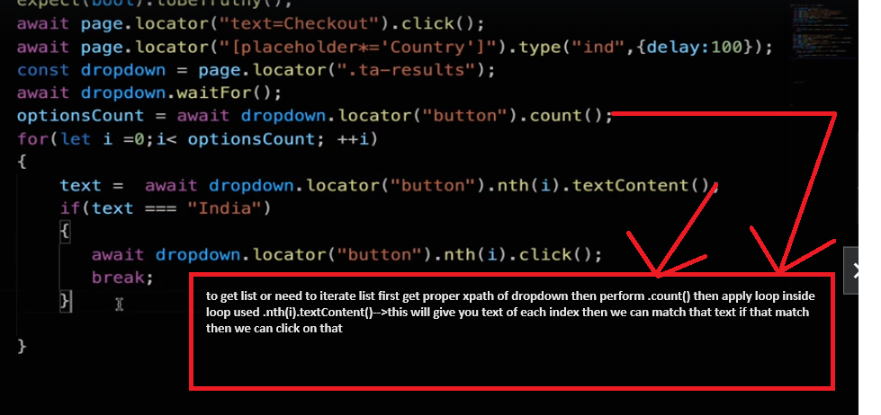

## **Checkbox** 🡪 we can use define method of tobeChecked(); for assertion we can use expect of playwright. 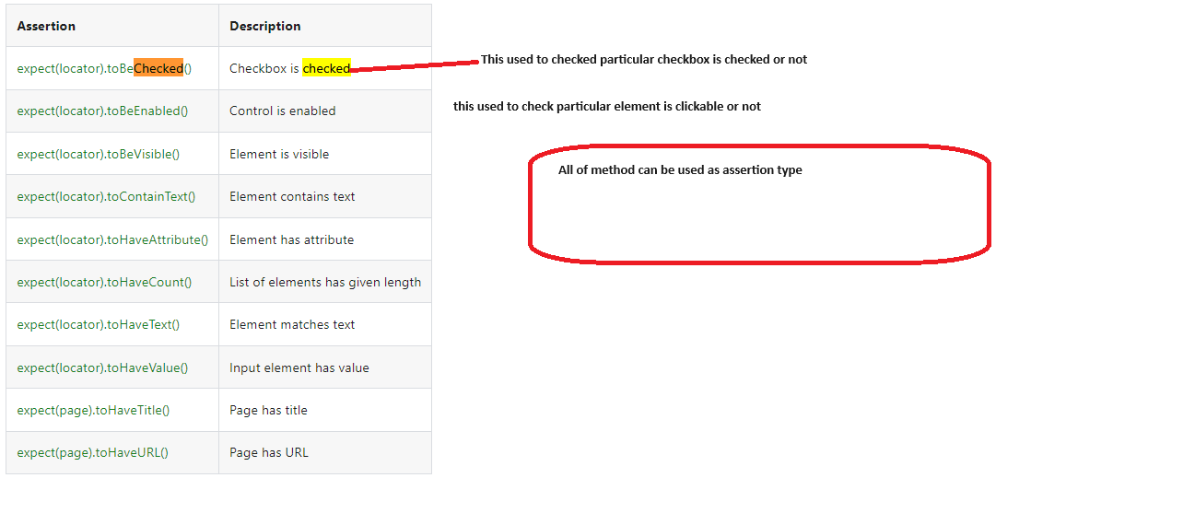

NOTE:

* If you want to uncheck any checkbox we can use uncheck() method.

Example: await expect(locator).uncheck();

* We don’t have any method to validate uncheck button ,but if we want to validate we can user following way

Example : expect(await expect(locator).ischecked()).tobefalsy();🡪this will return false as radio button is unchecked.

**We can also check attribute value as well**

Await expect(locator).toHaveAttribute(“attribute name which need to validate”, ”attribute value ”)

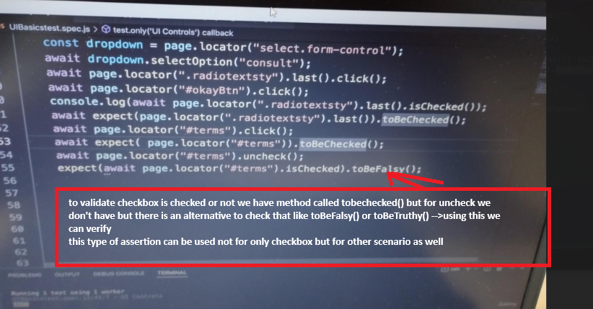

## **Child window and Tab Handling in Playwright**

* To handle new page we can use existing method context.waitForEvent(‘page’)🡪waiting till new page getting loaded

Example: const pagenew=context.waitForEvent(‘page’);🡪Listen for new page

NOTE: the above line should be used before opening new page or tab because line we used it is just to listen new page.

* To make scripts sysnc in js we used await but if we want to 2 steps in async way that time we can used promises.

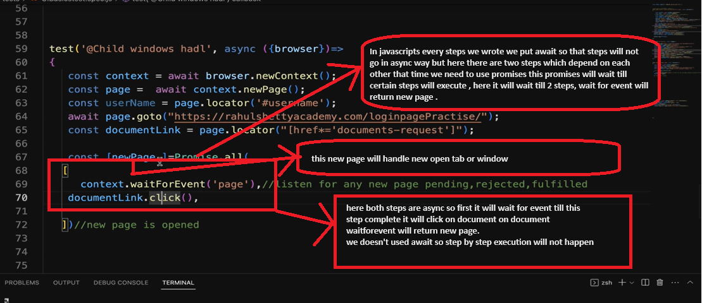

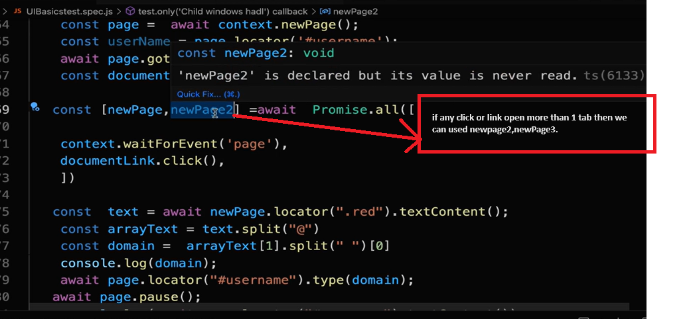

## Reports and Screenshots

* To get reports and screenshots no need to add extra code playwright has in build capability to do this thing.
* To get this we need to add this properties in playwright.config.js

Example: reporter: ‘html’,

Use: {

Browsername:’chromium’,

Headless:’false’,

Screenshot:Yes , apart from this we “**off**” or “**only-on-failure**”

Trace:’on’🡪if you want to know what happening at each step with complete log then we can use trace

Trace:’retain-on-failure’,🡪if you want traces only on failure then we can used this.

Trace:’on-first-retry’🡪logs will generated when retrying a test for first time

}

## Browser Navigation

* Suppose you open to url and after opening second you need to back to first url then like selenium in playwright we can you goBack method

Example:

page.goto(“”);

page.goto(“ ”);

page.goback();🡪it will back to first url

page.goForward();🡪so from 1st url it will go to second

**## to check element is hidden or visible or editable or clickable we have specific method using that we can check (url 🡪** [**https://playwright.dev/docs/actionability**](https://playwright.dev/docs/actionability)**)**

await expect(locator).toBeVisible();

await expect(locator).tobeHidden();

|  |  |
| --- | --- |
| [expect(locator).toBeAttached()](https://playwright.dev/docs/api/class-locatorassertions#locator-assertions-to-be-attached) | Element is attached |
| [expect(locator).toBeChecked()](https://playwright.dev/docs/api/class-locatorassertions#locator-assertions-to-be-checked) | Checkbox is checked |
| [expect(locator).toBeDisabled()](https://playwright.dev/docs/api/class-locatorassertions#locator-assertions-to-be-disabled) | Element is disabled |
| [expect(locator).toBeEditable()](https://playwright.dev/docs/api/class-locatorassertions#locator-assertions-to-be-editable) | Element is editable |
| [expect(locator).toBeEmpty()](https://playwright.dev/docs/api/class-locatorassertions#locator-assertions-to-be-empty) | Container is empty |
| [expect(locator).toBeEnabled()](https://playwright.dev/docs/api/class-locatorassertions#locator-assertions-to-be-enabled) | Element is enabled |
| [expect(locator).toBeFocused()](https://playwright.dev/docs/api/class-locatorassertions#locator-assertions-to-be-focused) | Element is focused |
| [expect(locator).toBeHidden()](https://playwright.dev/docs/api/class-locatorassertions#locator-assertions-to-be-hidden) | Element is not visible |
| [expect(locator).toBeInViewport()](https://playwright.dev/docs/api/class-locatorassertions#locator-assertions-to-be-in-viewport) | Element intersects viewport |
| [expect(locator).toBeVisible()](https://playwright.dev/docs/api/class-locatorassertions#locator-assertions-to-be-visible) | Element is visible |

**## Java/ Javascripts alerts and popup**

* In Playwright we need to tell scripts some event happening we need to handle it for that we can use on() method

**Example:**

* Page.on(‘dialog’,dialog=>dialog.accept());🡪 here it accept two argument first is it is event (here dialog box event of js) second what action we need to perform accept or dismiss();
* Page.on(‘dialog’,dialog=>dialog.dismiss());🡪

Example:

Page.on(‘dialog’,dialog=>dialog.accept());

Page.locator(“”).click(); 🡪 first we telling PW dialog will open so after clicking on that button it will accept that pop-up as we mentioned dialog.accept();

**## Mouse over**

* For this we have inbuild method to over on particular web element

Example: page.locator().hover()

Page.locator().click()🡪after hovering click on element

## Frame Handling

* Inbuild method is their framelocartor where we need to pass id of the frame

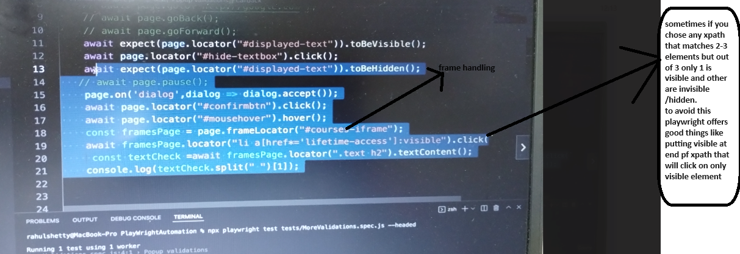

## Before tags in PW

1. Test.beforeAll();🡪suppose you have 10 test that need to run so whatever you write in beforeall() will run at once for all test
2. Test.beforeEach();🡪 suppose you have 10 test that need to run so beforeEach will run for each tes that you have.

## **API testing with PW**

* To use API in playwright we need to import request at start that will help for web api testing

Example: const{test,expect,request}=require(‘@playwright/test’)

NOTE: when you storing objects as javascripts object then properties will not have quotes only it’s value will have quotes

Exa: {username:”pravin”,password:”1654564”}

* To add token some info we can used method **addinitScript** where we can add values and token.

Example page.addInitScript(value =>{window.localStorage.setItem(‘token’,value)},token);

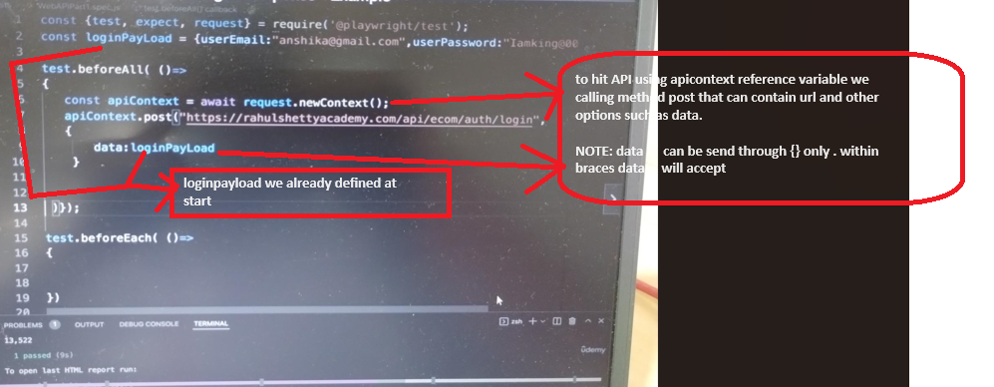

NOTE: data means payload,headers and other things that we passed while doing some calls through postman all things consider as data that need to wrap in {} only.

**## Session Storage and Intercepting network request/response with playwright**

* Sometimes it is difficult to bypass login in that cases we can do login through UI and once that done, we have playwright method called storageState this will keep all session data in form of json file.
* So, when we want to run next test cases where login required so no need to used login scripts, we can inject that json file to browser so it will directly login to application.
* This method needs to use/apply on context not on page as there can be many pages, but context will be one (context means browser)

NOTE: this way we can use when login is very complexed and we need to pass multiple parameters through header or token in that case we can use storageState where we can pass multiple parameter in single instance easily, it’s our choice and situation how to use **addinitScript** and **storageState**.

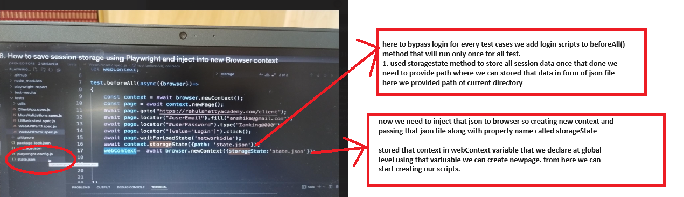

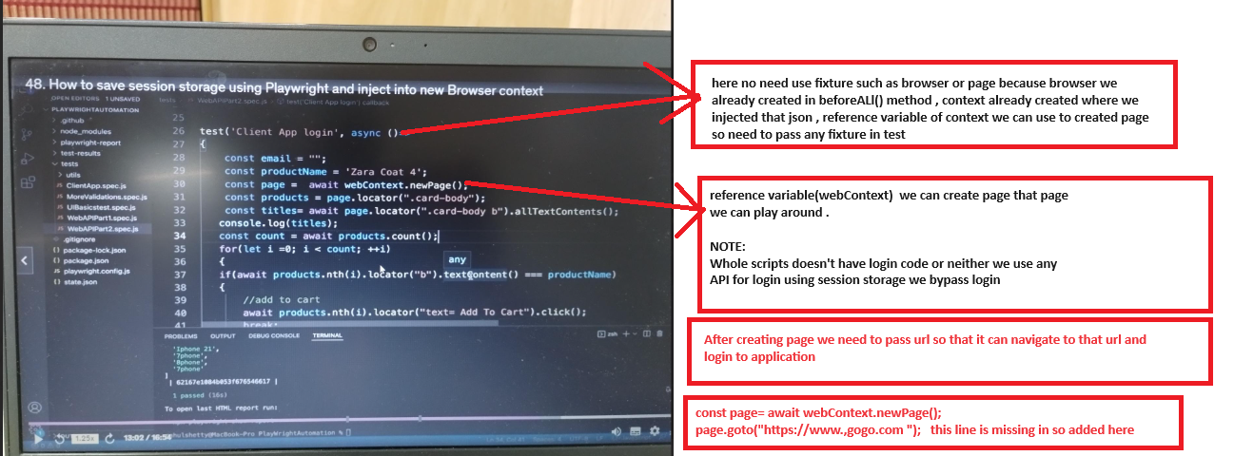

## **Debugging for API +Web Scripts(shift+ctrl+p)**

* Playwright debugger only debug scripts related to web , so debug scrips API +Web then go to playwright.json package🡪under scripts 🡪test🡪add command “npx playwright test tests/your test case name.js --headed” 🡪 do shit+ctrl+p 🡪 select debug:debug npm script🡪 scripts will start debugging

## **Intercepting network response call in PW**

* Using PW we can make fake response or we can Moke response to make our test cases passed on some criteria. Without disturbing or deleting previous data.

## **Screenshot in PW**

1. **Screenshot of full page**

* We have inbuild method for screenshot page.screenshot({path : ‘path of sc’})

Example: page.screenshot({path:’’});

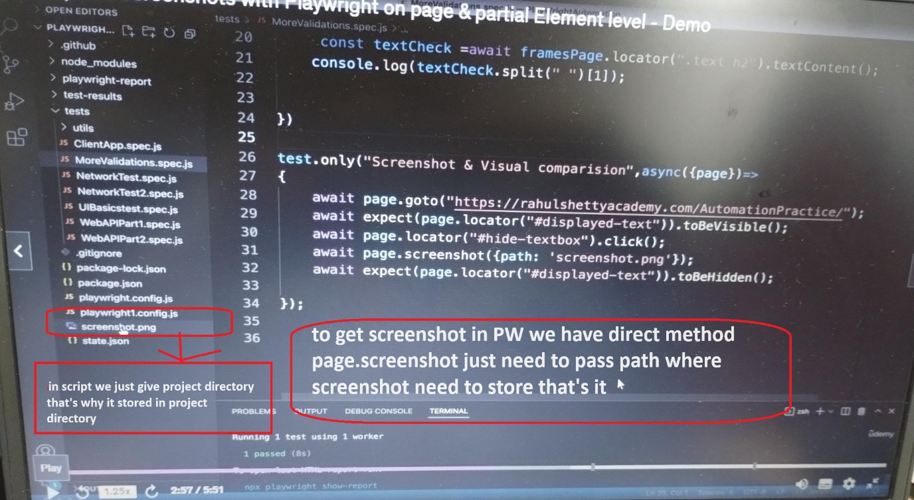

1. **Screenshot of Particular element**

**Example: page.locator(‘#usernmae’).screenshot({path:’’});**

**## Visual Testing**

* Suppose we ran a test and capture and store screenshot, again day after tomorrow you ran same test case capture and store screenshot so now we need to compare both screenshot whether both are same or different in scenes like alignment ,pixels ,button etc as user visually see that same thing we can do in PW

NOTE:

* Whenever you want to do visual testing by comparing 2 screenshots make sure it always has same UI as if you comparing screens of some news channel page then that it will get fail every time UI will be different, news may get change.
* You correctly use this concept for comparing screenshot.

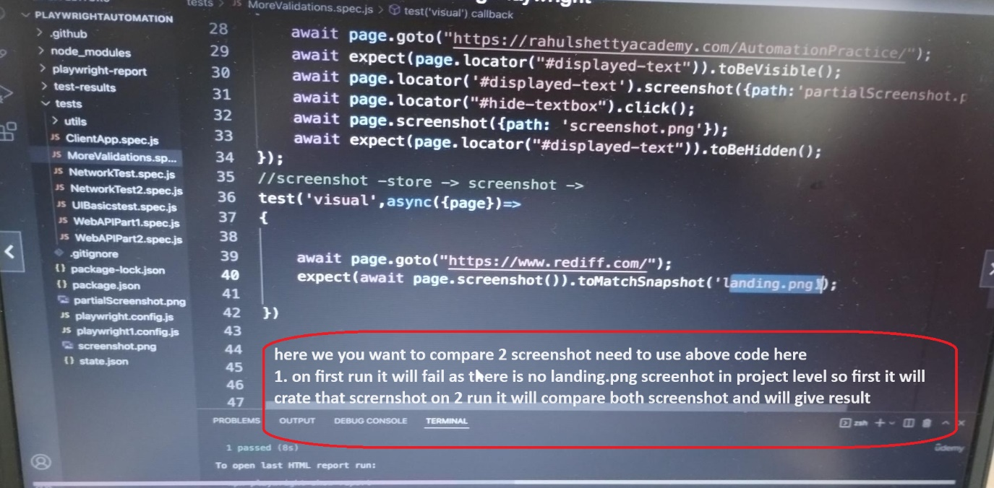

* By chance it got fail then we can check difference between 2 screenshot that will be present under test-result folder with proper naming conventions.

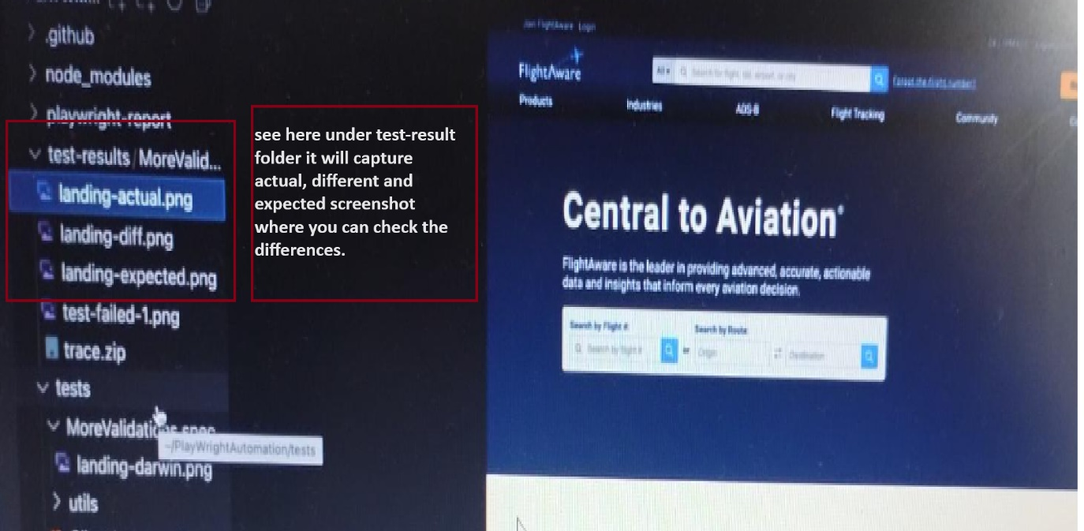

**## Page object manager**

* You created separated classes for each pages so in test class we need to call that class by creating object of it’s , suppose you have to call 10 classes then we need used new keyword 10 times to avoid this we can put object creation in object manager class and using object reference of manager class we can call respective class

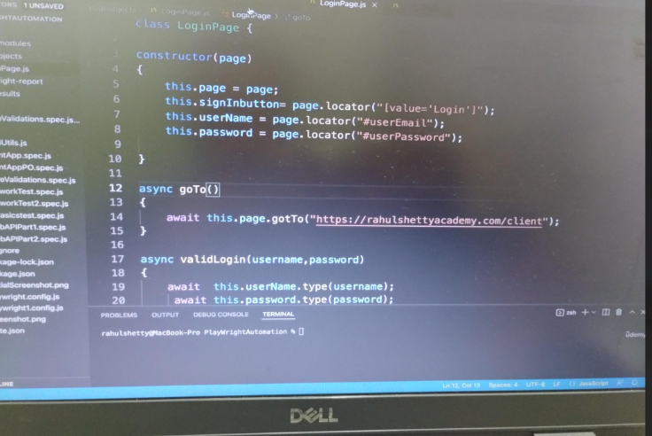

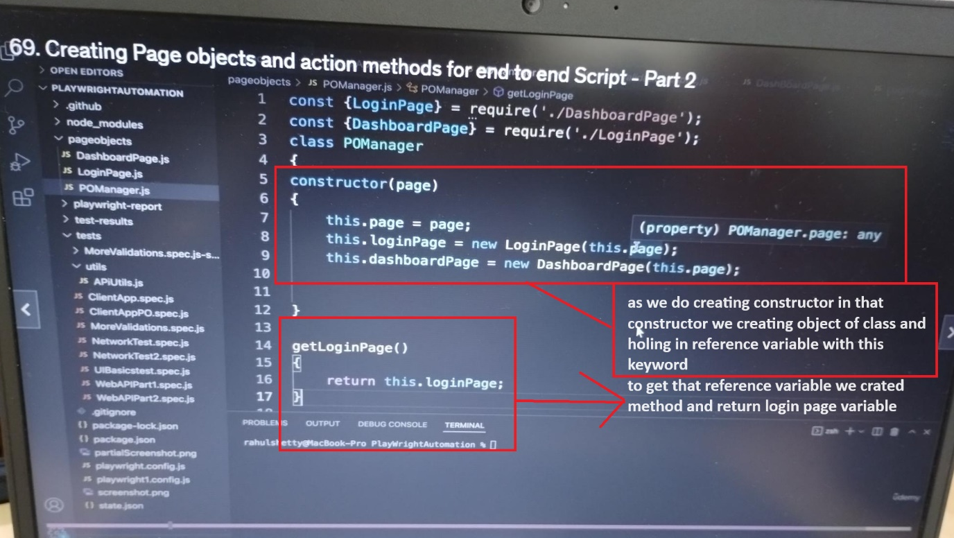

* Above way we can create PO manager to used that PO manager in test class check below screenshot

NOTE:

* When we need to access any class we need to create object of it and need to import that class , so if we have 1000 classes then we need to import 1000 classes so avoid this po manager come into picture using po manager just we need to create import po manager 🡪 check below screens

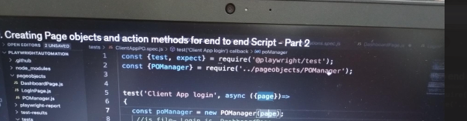

* Then just create po manager class object and using that class reference we can call respective method, like below

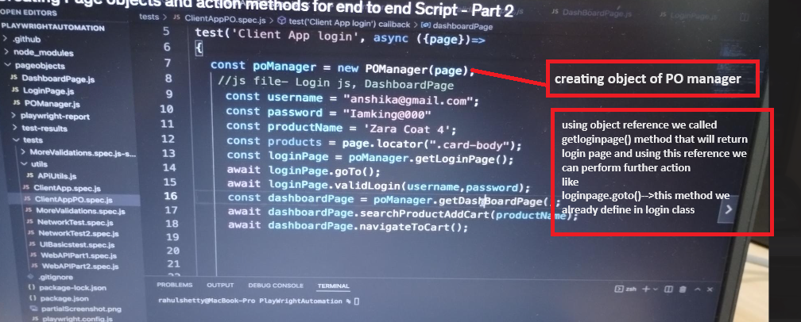

**## Various option and settings use in config file**

* We can create multiple playwrightconfig file based on our requirement but while running test we need to tell which config need to pick if you didn’t specify any config then it will pick default config.
* To specify which config need to pick we have following command

## how to run scripts when you have multiple playwright.config files

Example: tests/your test case name.js🡪under test folder testcasename.js file is present

npx playwright test tests/your test case name.js –config playwright.config1.js

NOTE:

* Just for small changes we are creating config file so to avoid this we can do some changes in original config like we can parametrized config file
* 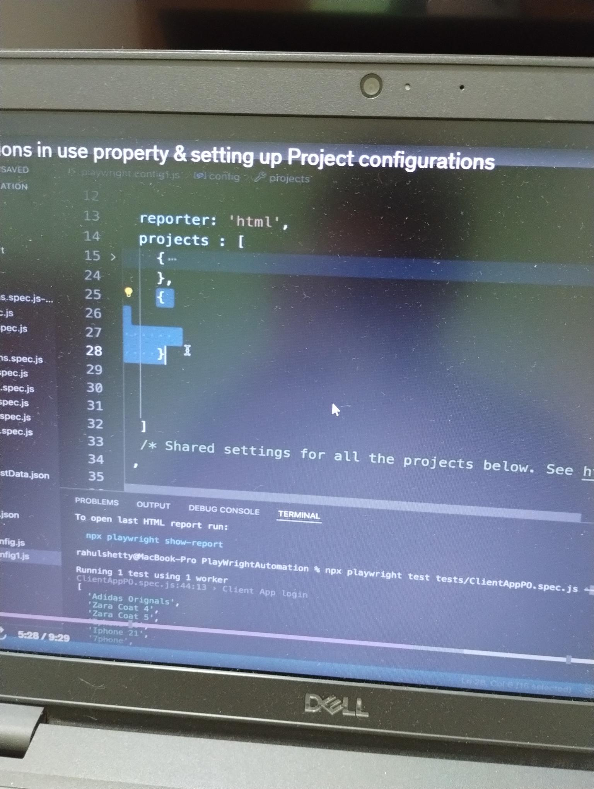
* Inside project we can create array that which have different parameter on which project will run like we want to run on webkit and headless mode=off, 2. Want to run on chromium and headless mode=true such we can parametrized in playwright configuration file

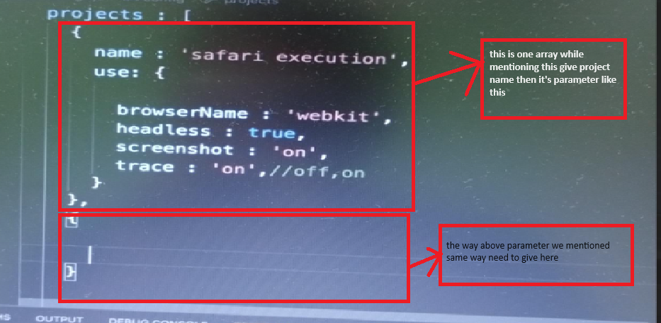

NOTE:

* Now if you want to run your project in safari or chrome then we can specify that in command

Example:

npx playwright test tests/your test case name.js –config playwright.config1.js –config playwright.config.js –project=safari 🡪project will run on safari browser with specified configuration that we mentioned under project array.

* If we didn’t specify any project, then it will run for all project array that we mentioned so like here we have 2 array then it will execute 2 times one for safari 2 for chrome.

Example: npx playwright test tests/your test case name.js –config playwright.config1.js –config playwright.config.js

## Web-Responsive (by changing browser size we check its functionality 🡪 whether application is mobile friendly or not by reducing browser size)

* To open browser in required mode or size then we have option viewport that we can mentioned in plwaywright.config file

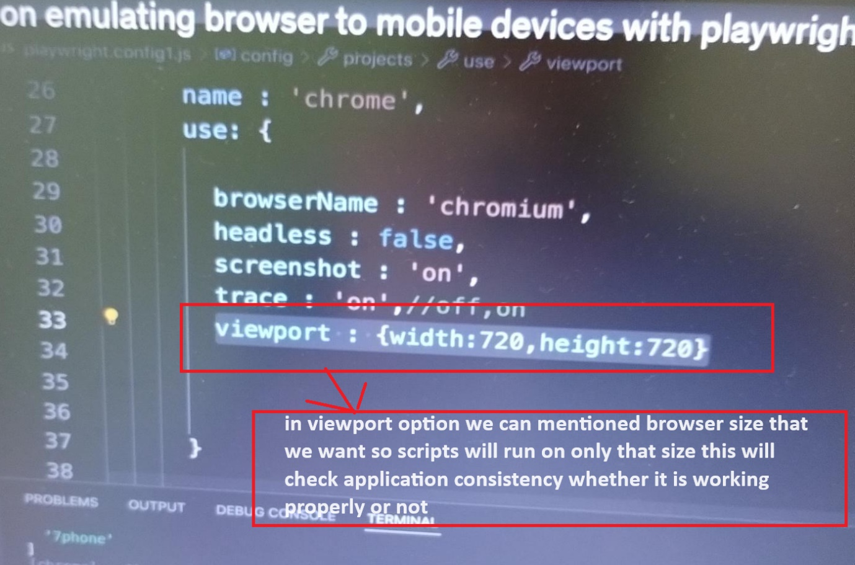

* We have another option as well where we can tell playwright open scripts in specific mobile screens the screen size will take care by playwright not by user.
* Devices name mentioned on our choice like if we want to run on pixel or Samsung then just provide mobile name in devices [‘’] script will run that mobile size

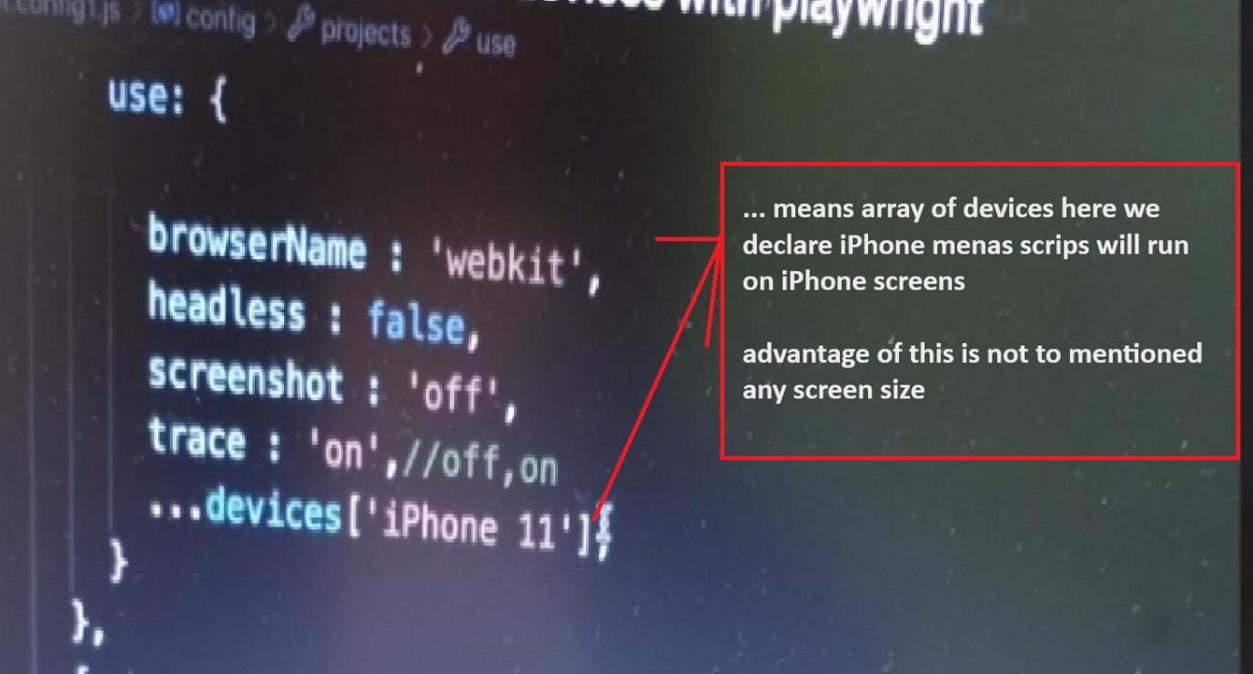

**## Handling SSL certification**

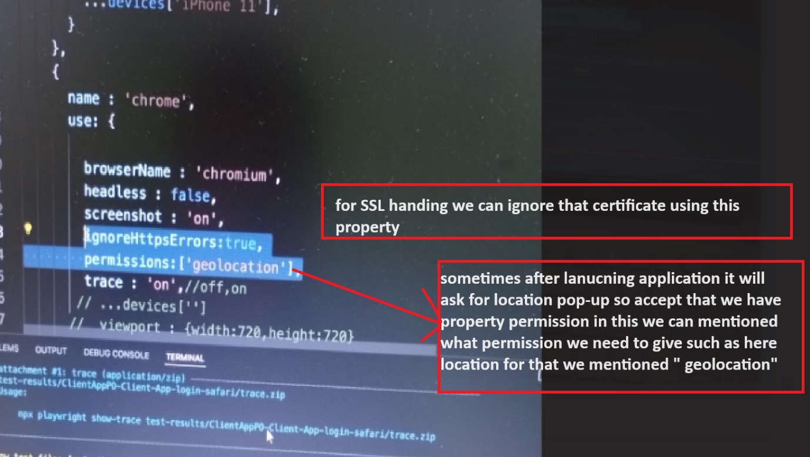

### **Video recording in Playwright**

* **Add video property where we added screenshots,browsername,headless,traces etc add property and it’s appropriate value below**
* **Same options are applicable for traces as well**

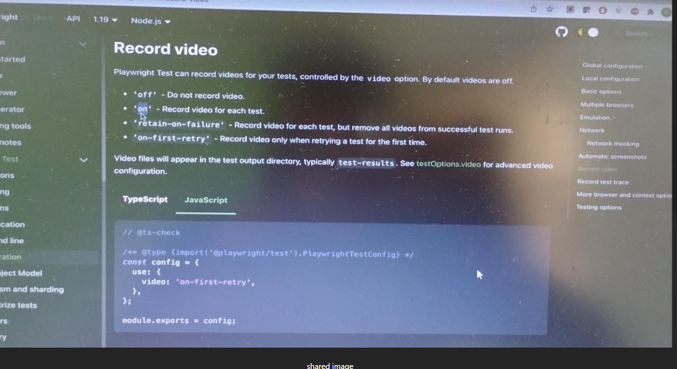

**## Test Retries, Serial & parallel execution and tagging in tests.**

1. **Retries**

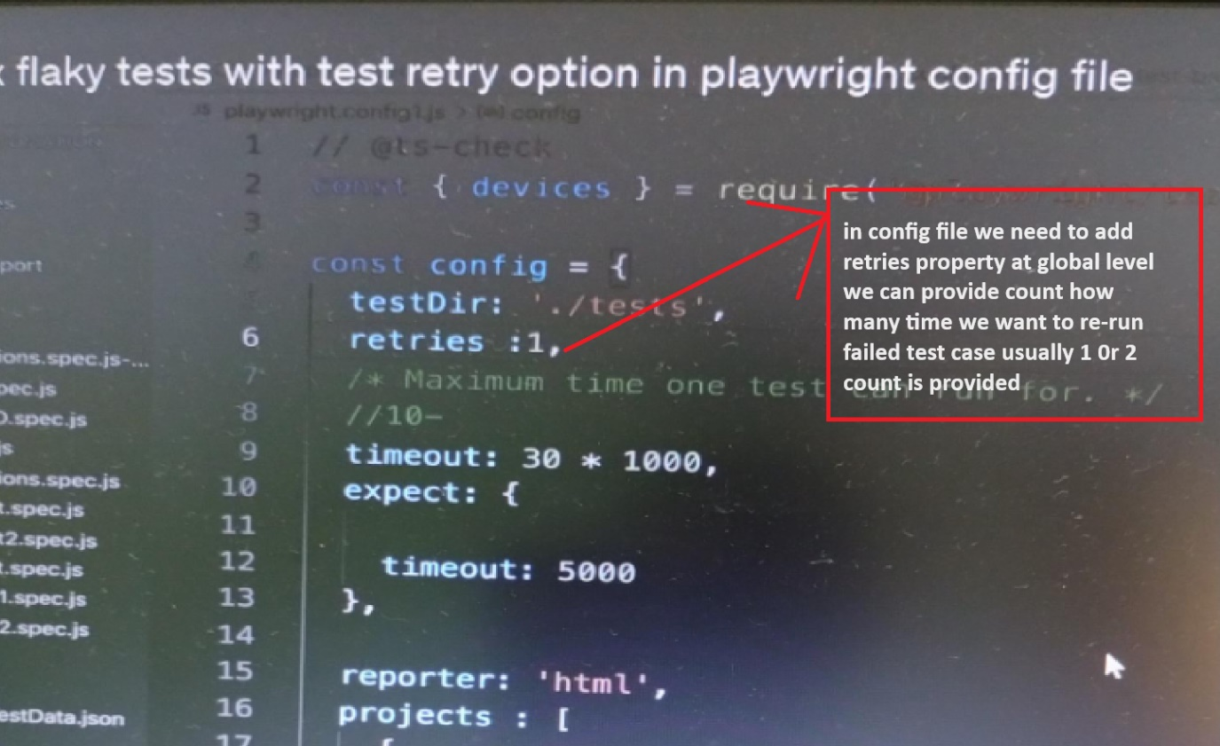

1. **Serial and parallel mode**

**NOTE:**

* **Test files that present under test folder will trigger parallel.-->whatever**
* **Individual test that present in js file will run in sequence**

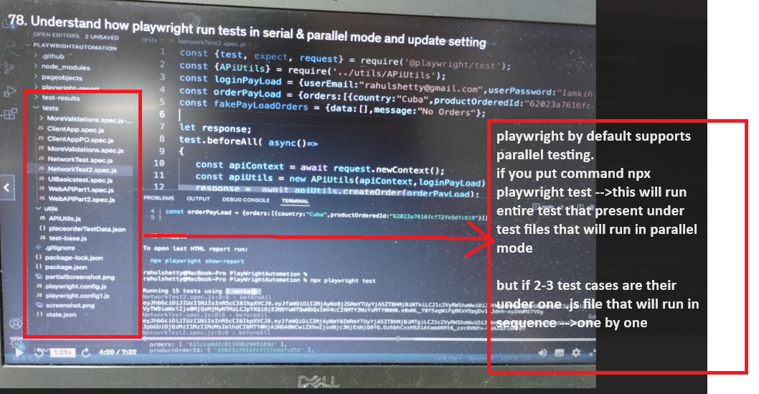

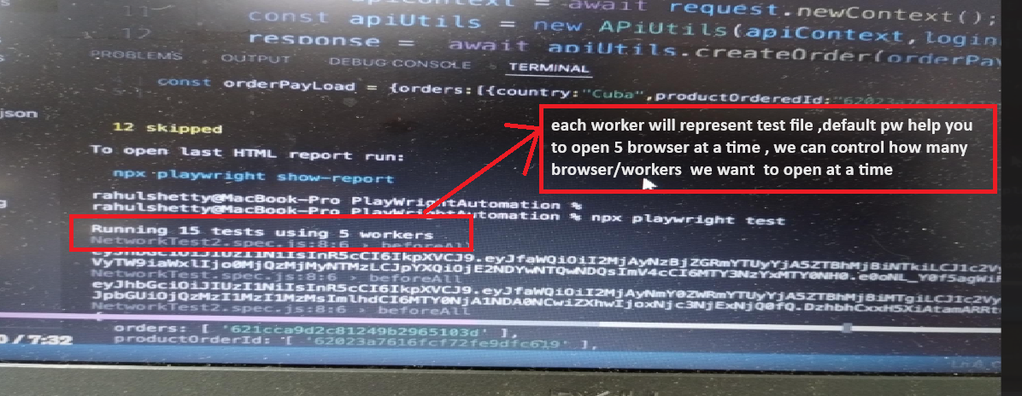

**NOTE:**

* **We can change workers/browser count default pw will open 5 browser but if you want 1 or 2 0r 4 then we can declare workers:3 🡪that means 3 browser will open at a time 🡪this we can define in playwright.config file (need to declare this workers count at global level like we declare it for retires)**

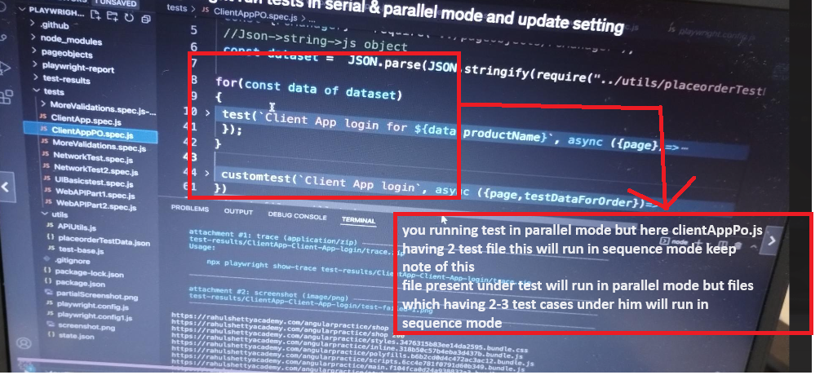

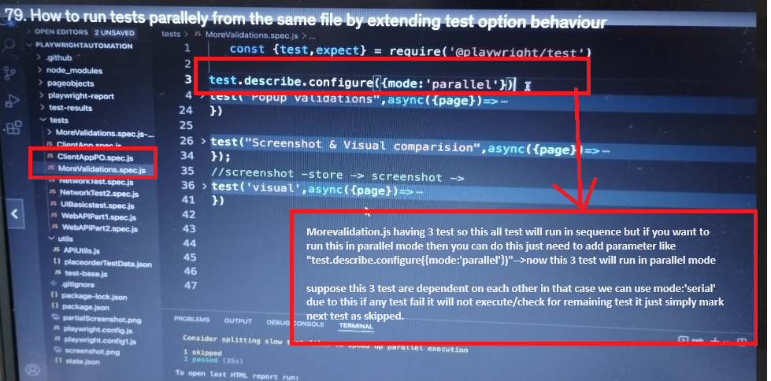

**## Race Condition**

* **When 2 test behaving /doing same thing with data or same login credentials then so sometimes we observed race condition that may failed your test case so to avoid this we can skipped duplicate test case**

**Example: test.skip();🡪skipping duplicate test case**

**## Playwright Special Locators**

* **GetByLabel: if text present under label tag or anything under label tag for that you can use this type of locator**
* **Nowdays page is design in way that if you click on text of radio button/checkbox /dropdown that will get clicked so due to this GetByLabel will be useful to perform that operation.**

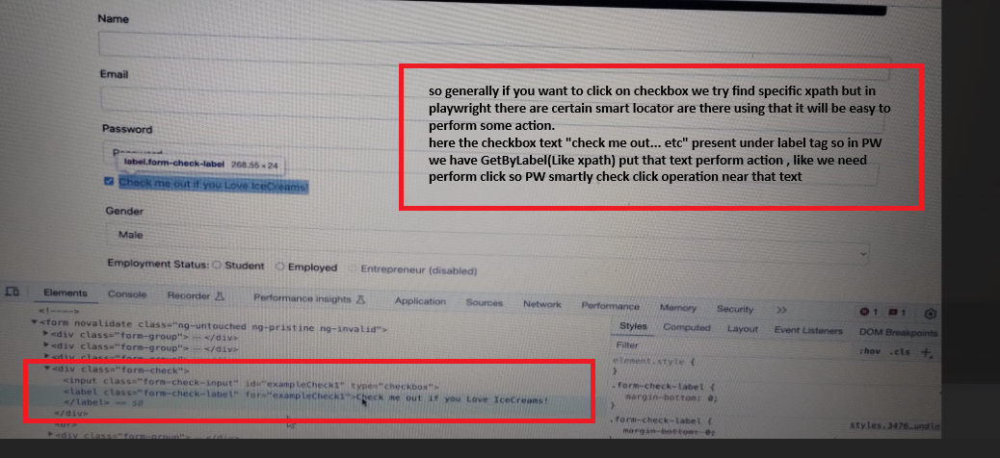

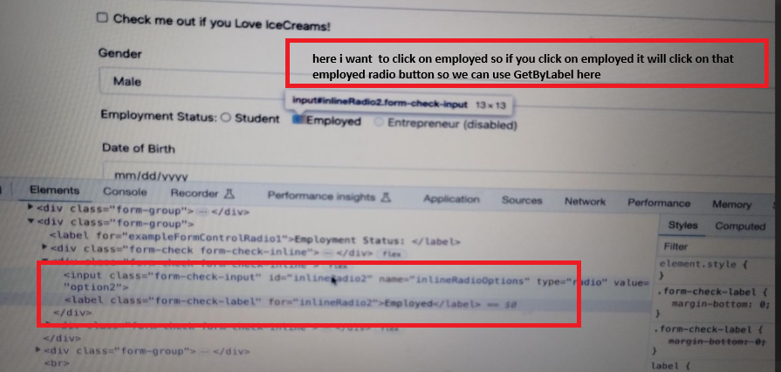

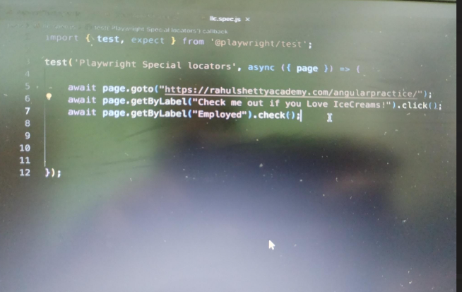

* **GetByPlaceholder:if page DOM structure having this attribute then we can use this type of locator**

